Champlain Islands Parent Child Center
Family Handbook

114 South Street South Hero, VT 05486
Red Building: 802-372-4704 Allen House: 802-372-5042 Fax: 802-372-8622
2020-2021
www.cipcc.org

TABLE OF CONTENTS
 | Page number
Address, phone numbers, hours of operation | 4
Welcome | 5
Center Mission & Philosophy | 6
What makes our Educators special? | 7
What makes our program special? | 7
Accreditations | 8
Things Your Child Will Need | 8
Classroom Placement | 9
Frequently Asked Questions | 9-10
Individual Classroom Curriculum | 10
Parent/guardian responsibility | 10
General Information | 10
Assessments | 10
Birthdays | 10
Biting | 10-11
Breastfeeding | 11
Check-in/out procedure | 11
Cleaning | 11
Communication | 11
Confidentiality | 11
Discipline/Behavior management | 11-12
Emergency closings | 12
Feedback | 12
Field trips | 12
Fire drills | 12
Food/Food program | 12
Infant food program | 12-13
Grievance Procedures | 13
Handwashing | 13
Immunization records | 13
Insurance | 14
License | 14
No Smoking | 14
Non-discrimination policy | 14
Open house | 14
Outdoor play | 14
Parent conferences | 14
Pick up | 14
Late pick up | 14-15
Records | 15
Rest time | 15
Safety | 15
Schedules | 15
School calendar (planned closings) | 15
School closings/delayed openings | 16
Social Events | 16
Special needs & disabilities | 16
Staff | 16
State regulations | 17
Sudden Infant Death Syndrome | 17
Toilet learning | 17
Toys from home | 17
Tuition information | 17-18
Visiting | 18
Withdrawal | 18
Child Abuse/Neglect Obligation | 18
Health Policies | 18-20
Medical emergency procedures | 20-21
Waiting list guidelines | 21
Signature page | 22

Champlain Islands Parent Child Center
114 South Street, South Hero VT 05486
Red Building: 802-372-4704
Allen house: 802-372-5042
Fax: 802-372-8622

Hours of Operation: 7:30 am – 5:00 pm

Welcome!
Thank you for your interest in the Champlain Islands Parent Child Center. We welcome you to a group of families and early educators dedicated to providing a safe, happy and high-quality environment for infant, toddler, preschool, and school-age children.
This guide is to answer your questions, to familiarize you with our program, its philosophy, mission, procedures and policies.
At CIPCC, families are encouraged to talk to their child’s teacher about their day, their needs and interests both at home and at school. We encourage you to ask questions, get involved, and be an active member in your child’s learning. Please, let us know your questions, likes and dislikes, and if you would like to make changes to our program. You are encouraged to attend our family functions, our parent informational meetings, and especially volunteer your time inside a classroom. Please know that you are respected by everyone at CIPCC and your contributions are valued.
If you have an interest that you would like to share with the CIPCC community, please see your child’s teacher or the director and we can discuss ways you can volunteer.
Welcome to our family,
Katie Brown
Executive Director

Our vision continues to be focused on building strong children and confident families.
Our mission is to partner with families in offering a safe, nurturing and rich learning environment where children feel confident to explore their surroundings through play and to guide each child in reaching his/her full potential as citizens of our world.
Our Philosophy on Education
Children are capable learners and each child is unique in how they approach their world. We approach teaching by first considering the “whole” child, providing a play- based, emergent curriculum that aligns with the Vermont Early Learning Standards. The curriculum evolves depending on the interests of the children, families and teachers. Our planning allows us to be intentional about providing children balanced and varied activities, including opportunities to learn how to function effectively within a group while still being accepted as individuals. We create an environment:
❖ that fosters caring and understanding of others with opportunities to celebrate diversity, problem solve, work together as a team and to build a caring community. As children learn to communicate with their peers and problem solve in a peaceful manner, academic learning progresses naturally.
❖ that is child friendly, safe, caring and comfortable.
This stimulating environment promotes developmentally appropriate and research based experiences in the cognitive, language, social-emotional, fine motor and gross motor areas. Another aspect of our curriculum includes involving families, friends, teachers and other community members into our learning community. This includes a shared care-giving partnership with families, recognizing the parents as their child’s first teacher. We believe this approach to children’s learning will result in each child reaching his/her full potential as citizens of our world.
TO ACHIEVE OUR MISSION WE WILL...
❖ Provide a safe, friendly environment with professional educators.
❖ Introduce developmentally appropriate activities that challenge and engage.
❖ Provide opportunities for physical activity.
❖ Introduce the skills necessary to problem solve and be a productive member of
a group.
❖ Provide an empowering atmosphere where each child takes responsibility for
his/her actions and accomplishments.
❖ Celebrate creativity and imagination, allowing each child to be the true creator of his/her own special masterpiece, whatever the activity.

WHAT MAKES OUR EDUCATORS SPECIAL?
We are proud to employ qualified and professional educators who are committed to the teaching and care of young children.
OUR EDUCATORS BELIEVE WE MUST:
❖ Listen to and talk with children in a meaningful and respectful way.
❖ Be involved in children’s activities, games and projects as a facilitator rather
than a director.
❖ Allow each child the freedom to safely explore his or her world.
❖ Recognize the importance of working in a partnership with families that respects
family traditions and values.
❖ Provide children with acceptable alternatives for inappropriate behavior.
❖ Take a pro-active approach to classroom management by anticipating potential conflicts and modifying the environment, rather than only responding to a negative situation.
❖ Encourage every child to be a team player by trying his or her best, encouraging others to do the same and helping a friend in need.
❖ Model and reinforce demonstrations of acceptance, patience, tolerance and
kindness by exposing children to a variety of small and large group activities, games, and sports.

WHAT MAKES OUR PROGRAM SPECIAL?

❖ A child-centered approach responds to the changing interests of each child. Our educators modify and enhance curriculum based on current educational theory to ensure quality early education.
❖ We maintain the State of Vermont preferred educator to child ratios to ensure quality interactions and safe play.
❖ We integrate music and movement, cardiovascular exercise (running and aerobic) and introductory organized sports into our daily routine.

ACCREDITATIONS
CIPCC is accredited by the National Association for the Education of Young
Children (NAEYC). CIPCC has earned 5 Stars through the State of Vermont Step Ahead Recognition Program.
THINGS YOUR CHILD WILL NEED
IT IS VERY IMPORTANT THAT YOU MARK YOUR CHILD’S NAME ON EVERYTHING YOU BRING TO SCHOOL (clothes, coats, boots, diapers, wipes, etc.)
❖ Sneakers or durable footwear (flip flops are prohibited)
❖ A set of extra clothes (seasonally appropriate)
❖ Diapers/wipes
❖ Crib Sheet and Blanket (must go home to be washed weekly)
❖ Seasonal outdoor clothing
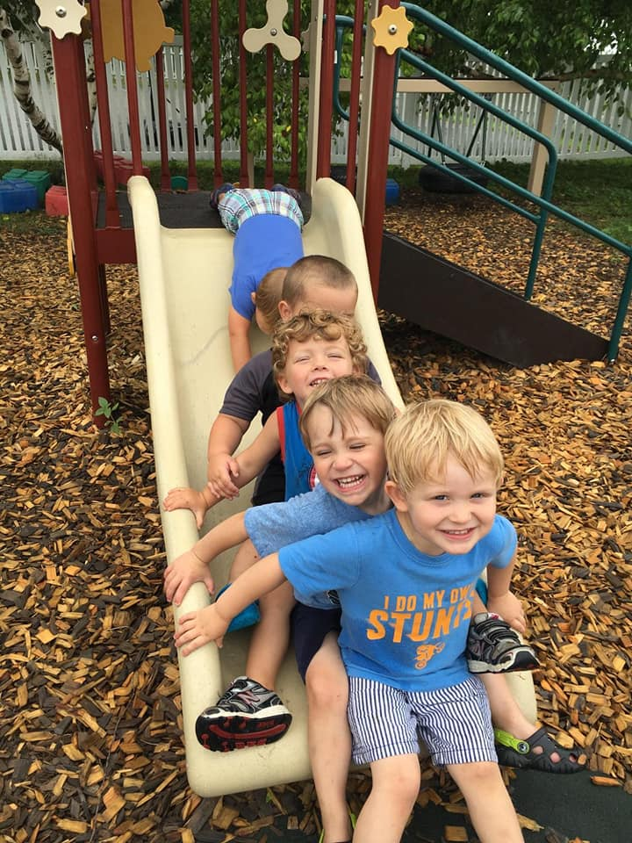
❖ Water bottle

SUMMER
❖ Sunscreen
❖ Water bottle
❖ Visor or baseball cap
❖ Swimsuit, towel, backpack (water shoes optional)
❖ Swim diapers (if needed)

WINTER
❖ Snowsuit/Snow pants
❖ Mittens/Gloves
❖ Hat
❖ Boots
In addition to this list, each individual classroom has a “Welcome Letter” that names more specific items your child may need.

WHAT DETERMINES MY CHILD’S CLASSROOM PLACEMENT?
Many centers base a child’s placement entirely on age, abruptly shifting children to a new classroom with higher adult/child ratios with each new birthday. We believe that strong relationships require time to develop and evolve. In order to provide continuity of care for children birth - age three, every June or September your child will transition to the next classroom with their peers and teachers. The September following their third birthday, your child will enter the preschool classroom.
Our goal is to provide your child with the greatest opportunity to learn with
confidence and develop social relationships. As we get to know your child and observe how he/she interacts with his/her peers we can create a learning environment where every child in the group is both challenged and empowered. Throughout the year the goals and experiences of the group will change to reflect the rapid development of young children.

FREQUENTLY ASKED QUESTIONS:
❖ Will my child cry when I leave? It is very common. If you reassure your child that he/she will be safe at school and let her/him know when you will return to pick him/her up, we can handle the rest! We will be happy to call and let you know how your child is getting along in the activities of the day. To help in the transition, we encourage you to observe the classroom, meet the educators, and then visit the center prior to your child’s first day.
❖ What happens when my child has a temper tantrum or what happens if my child is aggressive with another child? Staff shall use positive methods of guidance and discipline that encourage self- control, self-direction, self-esteem and cooperation (for example, redirection, planning ahead to prevent problems, reinforcing and praising appropriate behavior and encouraging children to express their feelings and ideas instead of solving problems with force). When a child is angry or upset he/she may need to express that by crying or spending a few moments in a quiet space. We make sure that your child is safe and encourage him/her to return to the group when he/she is ready.
❖ Will my child learn the alphabet and numbers? We will encourage your child to love and respect books, and to use writing tools regularly to develop control and strength. In addition, we provide literature rich classrooms and promote early writing and reading skills within a meaningful context, as opposed to encouraging memorization.
❖ Why does my child get so dirty at school? We encourage each child to explore his/her environment through a “hands-on” approach. The program includes activities such as painting, gluing, cooking, outdoor play, sand and water play. In addition, we encourage children to develop self-help skills by asking that they take responsibility for their own belongings and dress themselves whenever possible.
INDIVIDUAL CLASSROOM CURRICULUM
Our program is proud to offer a range of learning experiences that promote social, emotional, intellectual, and physical growth. Our philosophy recognizes that each child is an individual with ideas and interests worthy of our respect and responsiveness. In addition, we believe that the key to our success is in working in partnership with you. We welcome your insight and invite you to be involved in the planning and implementation of your child’s curriculum.
Your child’s educators will communicate with you through-out the year about general guidelines and goals in relation to developmentally appropriate activities and practice. We integrate Creative Curriculum into all our classrooms and scaffold those lessons to meet the developmental needs of our students.
PARENT/GUARDIAN RESPOSIBILITY
• Sign in/out daily
• Close gate
• Volunteer 1 hour per quarter (give ideas; reading, painting, crafts, music, mowing, cleanup). Total of 4 hours per year.
GENERAL INFORMATION:
ASSESSMENTS: Your child will be assessed using the Ages and Stages Questionnaire, Teaching Strategies Gold (only for those who qualify under Grand Isle Supervisory Union’s ACT 62 Pre-K, EEE, EEI), and portfolios. All children will be assessed within 3 months of their start date as well as every November and May. These assessments are kept confidential and locked in your child’s file in the Director’s office and will be shared with families during parent conferences or if we have concerns regarding your child’s development.
BIRTHDAYS: We realize that your child’s birthday is a special day. We ask that families please not bring in dessert items for your child’s birthday. You may bring in a healthy, store bought snack to share if you choose such as fruit, frozen fruit juice bars, crackers, etc. You may bring in something special about your child for them to share about when they were born as well.

BITING: In group settings young children bite. When this happens we inform both the parent of the child who was bitten and the parents of the child who has done the biting. The name of the child who bit will remain confidential. When repetitive biting occurs, the educators, parents and director will work together to determine the cause of the biting (teething, frustration or aggression) and the course of action.
BREASTFEEDING: We support nursing mothers. Nursing moms are welcome to nurse their children where they are comfortable. If you would like more privacy, there is a chair in the infant nap room. Human milk may be stored in the infant room refrigerator for no more than 48 hours and in the freezer for up to three months. All frozen milk and bottles must be labeled with the child’s name and the date. All formula and human milk that is served but not consumed must be discarded after one hour.
*Please see “FOOD PROGRAM” section for further information on the Infant Food Program.
CHECK IN/OUT PROCEDURE: For safety reasons and to enhance communication, please sign in and out at arrival and departure times with your child’s educator. The State and NAEYC require that your signature is on our sign-in/out sheets. Please call us by 9 AM if your child will not be attending school or if your child will be late.
CLEANING: The facilities, classrooms, toys and equipment are cleaned and sanitized on a regular basis following State and NAEYC guidelines.
COMMUNICATION: The organization has a system for communication. Teachers will regularly send home communication sheets, newsletters, field trip information and accident report forms. They are also available to speak with you when they are not with children. The best time to reach your child’s teacher by phone is between the hours of 12:30 and 2:30 (nap time), otherwise it may be necessary to take a message and your child’s teacher will return your phone call as soon as possible.
CONFIDENTIALITY: Confidentiality in regard to child/family records, information and confidential conversations will be maintained. All information will be locked in a file in the Director’s office. We also expect parents to respect the rights of other families in the center by maintaining privacy and confidentiality.
DISCIPLINE/BEHAVIOR MANAGEMENT: We create a safe and enjoyable environment for all children. Clear limits are set and re-direction will be used to help children find appropriate alternatives to disruptive behavior. We listen to and talk with children in a meaningful and respectful way. When children need assistance, we guide them in conflict resolution with their peers. We provide children with acceptable alternatives for inappropriate behavior. We take a proactive approach to classroom management by anticipating potential conflicts and modifying the environment, rather than only responding to a negative situation. To be most effective, we encourage parents to be an active part of this process. To prevent disruptions, we will contact parents when behaviors are observed, and we will work together toward developing an action plan. Behaviors that cause physical harm to other children and staff will require more immediate disciplinary action. The director reserves the right to adjust schedules for the protection of your child and others. This may include children leaving the center if the action plan is not working and all alternatives have been explored. If a parent has concerns regarding a behavior they observed of a child other than their own, he or she should inform the teacher or director directly rather than disciplining the child themselves. This ensures that appropriate course of action will be taken by the staff.
EMERGENCY CLOSINGS: CIPCC may need to close the center for emergencies such as a lack of electricity, heat or water. Parents will be called to pick up children within a designated time.
FEEDBACK: Your feedback is helpful in building an excellent program. Initial concerns and/or complaints are best handled when directed to the primary educator and director. Parent/Teacher conferences are scheduled twice a year, typically in the winter and spring. Parents may request additional meetings with the teacher on an as needed basis.
FIELD TRIPS: Written parental permission is required. A permission form is included in the enrollment packet to have on file. Parental chaperones may be needed in order to go on field trips. If parents choose not to have their child participate, they may bring their child to the center when the class returns or wait at school with their child. Due to space limitations joining another classroom is not an option. If you plan on being a chaperone for a field trip at any time during the year, we’d love to have you do so. Please sign the permission form and supply us with a copy of your license and insurance card before helping us to drive your child’s classmates.
FIRE DRILLS: Fire drills are performed on a monthly basis. When these happen we will let you know in the daily notes. All staff are knowledgeable of the drill procedure. There is an instruction/log book for documentation.
FOOD: Food allergies MUST be shared with the educators and the director. Due to allergies we are a peanut and tree nut free center.
FOOD PROGRAM: CIPCC is a participant in the Child & Adult Care Food program (CACFP) and provides meal benefits to all enrolled children who are 6 weeks of age and older. We offer a nutritious breakfast, lunch and afternoon snack according to The Vermont Department of Education Child Nutrition Program guidelines. Meals are served family style and staff and children eat together. Breakfast is served at 9:00 a.m. If your child arrives before 8:00 a.m., and you are unable to serve him/her a breakfast at home, we ask that you supply a small, nutritious breakfast upon arrival. Breakfast ideas can include a fruit or vegetable, bagel, toast, yogurt or non-sugary cereal with white milk. Prohibited foods are: Juice (unless 100%), flavored milks, doughnuts, pop tarts and other high sugary foods.
INFANT FOOD PROGRAM: We are excited to inform you that our Food Program is expanding and that we will be offering the food program to children under 1 beginning August 1st 2014. Participation in the INFANT food program is optional and families can choose to opt out if they want, however participation is highly encouraged.
If you choose to participate the following will be provided to your child:
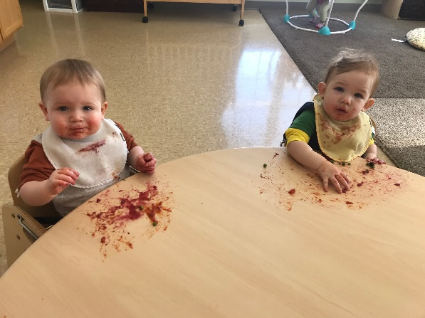
❖ Kirkland Signature Formula
❖ Beech-Nut Infant Oatmeal Cereal
❖ Breast milk- If your family is choosing to breastfeed you can still participate in the program and any educational opportunities offered.
❖ Pureed and finely chopped options of what is being served for breakfast, lunch, and afternoon snack.

There are different meal patterns associated with each stage of infancy. Copies of the meal patterns will be available in the office. Below are the details for these patterns but we would honor each child’s needs:
❖ 6 weeks through 3 month – We would only offer breast milk or the Kirkland formula as often as every two hours.
❖ 4 months through 7 months – We will continue to offer breast milk or formula, with the addition of infant cereal and pureed fruits and vegetables (optional).
❖ 8 months through 11 months – We will continue to offer breast milk or formula and infant cereal, with the addition of foods being prepared for the rest of the center.
GRIEVANCE PROCEDURES: Parental concerns should be shared with the educators initially. If a solution cannot be found, the director and/or (general supervisor) should be involved. Together the team will come up with a solution and set an appropriate timeline. If this plan does not work, the solution may be to end the child’s enrollment.
HANDWASHING: Children and families are expected to wash their hands upon arrival at the center to limit the spread of germs. Parents are encouraged to assist their children in establishing this routine. Throughout the day hand washing is required by staff and children upon re-entry to the building, before eating, after using the toilet or diaper changing, after handling animals or after outside play. Staff shall wash the hands of children who are unable to wash their own.
IMMUNIZATION RECORD: Current records signed by your child’s doctor are required prior to the start of the school year. They should be updated regularly as changes occur. If a waiver is needed for philosophical or religious reasons, please get one from the director.
INSURANCE: Champlain Islands Parent Child Center-South carries full liability insurance.
LICENSURE: We are fully licensed by the State of Vermont.
NO SMOKING: No smoking allowed on/in the premises; buildings and grounds.
NON-DISCRIMINATION POLICY: Champlain Islands Parent Child Center admits children and employs staff of any race, religion, disability, color, gender, sexual orientation, national and ethnic origin.
OPEN HOUSE: These are usually held during the month of October and again in the spring.
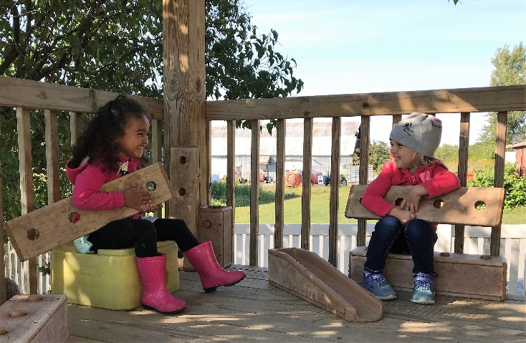
OUTDOOR PLAY: We go outside with your child at least twice daily when weather and air quality permit. We go outside when the temperatures are around 15 degrees Fahrenheit (including wind chill factor) and around 90 degrees Fahrenheit. Outdoor time will be limited to 20 - 30 minutes when the temperatures are between 20 to 32 degrees Fahrenheit. Please plan to bring your child appropriate clothing and foot wear for the outdoors.
PARENT CONFERENCES: Will be offered twice a year to discuss your child’s progress, accomplishments and goals, around June and November. Additional conferences may be scheduled upon request at any point in time.
PICK UP: Written authorization or a phone call to the teacher is required for non- guardians to pick up children. They will be asked to show I.D. before your children are released. Parents must ask in advance for early drop offs.
LATE PICK UPS: Our center has contracted times for families and our staff schedules are based off of those hours. So, please be prompt in picking up your child and exit the building by your contracted time (take into account the amount of time it takes for jackets, boots and snow suits). If you want to spend time checking your child’s cubby or talking with a teacher, please arrive a few minutes earlier. Staff members often have evening commitments and need to leave on time. Please respect this policy as chronic lateness will not be tolerated.
Our late policy is as follows:
❖ $1 per minute for the first 5 minutes (per child)
❖ $5 per minute after that up to the first 15 total minutes
❖ $10 per minute after that
Late fees MUST be paid the next business day. The child will not be permitted back in the child care program until late pick up fees are paid in full. If the lateness continues 2 or more times in a given month, your child’s enrollment may be suspended or hours changed. Extreme occurrences may be cause for termination of the enrollment contract. Early Drop Offs must be arranged in advance.
The clock in the centers hallway shall be used to determine the time.
RECORDS: All children’s records are kept in the Director’s office in a locked file. You may request to view your child’s records at any time. If you would like copies of your child’s records, please let the director know and they will be available for pick-up the next business day.
REST TIME: A mandatory one half hour rest period is required of all children, but no child is forced to sleep. Time and space is provided for quiet play for those choosing not to nap.
SAFETY: CIPCC staff is trained in first aid and Infant/Child CPR. In addition, there is an emergency response plan in place and a telephone available with emergency numbers posted.
SCHEDULES: Regular schedules are agreed to upon enrollment. If your schedule needs to change, we will accommodate as best as we can. Please provide a written request two weeks in advance.
We offer full time care only. We will consider part- time schedules based on availability. Part-time is considered 2 or 3 full days; anything more than 3 days is considered full-time as we cannot match up a one-day slot to make a full time slot. A family’s need to change their schedule from full-time to part-time will only be honored if we are able to match your schedule with another family’s schedule. For hours of operation please see page 3.
If you are granted a part-time slot, your days are subject to change at any time to meet the needs of the center, staff schedules and classroom (CIPCC will give you at least a two week notice of any changes made to your schedule).
SCHOOL CALENDAR (PLANNED CLOSINGS): At the beginning of each year, a calendar of scheduled closings including in-service days and special events will be distributed to parents. The centers will close for the following holidays: Presidents Day, Memorial Day, Fourth of July, Labor Day, Thanksgiving Day and the Friday that follows. If any holiday falls on a weekend, the center will be closed the Friday before or Monday after. These days will be included in your tuition and credit will not be given. The days CIPCC is closed for Christmas week and New Year’s Day will depend on how the days fall in a given year. Five days of this break will be tuition free.
Please call us in the morning if your child will not be attending school. If we do not receive a message from you by 9:00 am, we will assume that your child will not be coming and staff accordingly. We require students be dropped off by 9:00 am, to ensure they are at school for the academic part of the day. Failure to bring your child into school on time could result in denial of care for the day, please plan accordingly. This decision is left to the discretion of the Directors.
SCHOOL CLOSING: Champlain Islands Parent Child Center follows the Grand Isle Supervisory Unions school closing policy for severe weather conditions. In the event Grand Isle County experiences severe weather conditions and the school district is closed for vacation, it is the Director’s discretion to delay opening, dismiss early or close the center. Credit will not be given. Information regarding school closing or delayed opening will be broadcast on WCAX (Channel3) TV station. CIPCC will also post this closing on its Facebook page at https://www.facebook.com/pages/Champlain-Islands-Parent-Child- Center/226059570872865. The Director/supervisor on duty will call families regarding early dismissal.
SOCIAL EVENTS: Regular social events will be scheduled for the Center’s community to include staff, children and their families. If you’d like to volunteer to help plan and organize these events, your help will be welcomed.
SPECIAL NEEDS & DISABILITIES: We will make every effort to meet the needs of your child physically, emotionally, intellectually, and socially within our abilities based on our staffing, ratio and facility resources. We will work with families in making necessary plans to accommodate your children in our program as long as necessary or until it is determined that the arrangement is not working. Modifications and emergency procedures related to enrolled children with special needs shall be developed and maintained after consultation with the child’s parents and program/agencies providing services to the child.
STAFF: Staff and volunteers in the childcare program are screened for any history of child abuse or criminal activity and the State completes a background check on each individual. All staff counted in the staff/child ratios comply with the State and NAEYC teaching requirements, have a basic knowledge of child development principles and are First Aid/CPR Certified within the first six months of hiring. All staff participate in continuing education and meet their yearly requirements to fulfill their individual professional development plans.
Our teachers are the most knowledgeable people about children’s development and early education at the center, without them, none of the wonderful learning or experiences could take place. We encourage you to use them as a reference for your child’s learning, ask questions, share your likes and dislikes, and any changes that you would like to happen. We hire the highest qualified early childhood educators that we can find to offer you the best care and learning environment we can.
STATE REGULATIONS: Regulations are posted in the entrance. More information can be found at www.dcf.state.vt.us/cdd/licensing. Other early childhood program information may be found at www.brightfuturesinfo.org. If you have concerns regarding an early childhood program, you may call the Child Care Consumer Concern line @ 800-540-7942.
SUDDEN INFANT DEATH SYNDROME: To reduce the risk of SIDS infants shall be placed on their backs to sleep unless there are medical orders requiring alternative positioning. All infants sleep in cribs in the nap room of the infant classroom. The teachers will visually check on the sleeping infants every 10 minutes to ensure their safety.

TOILET LEARNING: Toilet learning needs and schedules are individualized. The educators work with the parents to communicate about each child and ways to support their success. As the toddlers become more interested in this and show some development, the class will work as a group, with each child given the opportunity to try when the class visits the bathroom for regular visits.

TOYS FROM HOME: Books are always encouraged. Special stuffed animals and blankets are acceptable at nap time. All other toys need to stay home.

TUITION INFORMATION: Tuition rates are subject to change at any time.
Program | Family Rate | Universal Pre-K weekly Discount (effective (September-June)* | Actual Tuition Cost
Infant/Toddler:
Full Time | $232.00
Part Time (when available) | $52.00 per day
Preschool:
Full Time – School Year | $182.12 | $95.88 | $278.00
Full Time – Summer | $232.00
Afterschool:
School Year | $93.00
Part Time (when available) | $27.50 per day
In-service days | Additional $19.00  per day
Vacations/Summer | $185
Part time camp | $42.50

All Full-Time families are entitled to a discount that breaks down as follows:
❖ Children contracted to attend 8 1/2 hours or less will receive a $10.00 discount
per week.
❖ Children contracted to attend 9 and 9 1/2 hours will receive a $5.00 discount
per week.
❖ Children who are 4 by September 1st and who reside in South Hero or Grand Isle will receive a discount on their tuition for the months of September - June based on a formula.
❖ Full-time families, who have more than one child attending the program, qualify
for a 10% sibling discount. The 10% discount will be applied to the lower tuition rate (this does not apply to children in the school-age program).

We welcome families with financial assistance. If your payment is subsidized we require a copy of your paperwork in advance. When your subsides are renewed or changed, it is your responsibility to submit the new paperwork. Your co-payments (if applicable) are due in advance and the subsidies are paid at the end of the month. Payments are expected on a pre-paid bi-weekly basis. If you are late with your payment we will need to discuss your scheduling options and make a payment plan. We have the discretion to adapt your schedule or suspend your child’s enrollment if the payment plan is not followed.
If your tuition payment is late but paid during the week after the Pay Monday, the late fee will be $10.00. If payment is made during the second week after the Pay Monday, the late fee will be $20.00. If the bank returns a check, the parent is charged both the late fee and a $10.00 returned check fee. If payment for contracted care is not received for two consecutive Pay Mondays, and no arrangement for payment has been made with the Director, the child’s contract will be cancelled and s/he will not be permitted to attend the program as of the second Pay Monday. Before the child may attend the center again, compensation must be made for the past two unpaid Pay Mondays as well as the current one, and new schedule arrangement must be made.
VISITING: You are welcome to visit your children and teachers at any time. You are also welcome to call and check on the status of your child at any point in time.
WITHDRAWAL: A two week cancellation notice in writing is required.
All employees at the Champlain Islands Parent Child Center are mandated to report any suspicion of child abuse. Together the Director and the employee witness will file a report to the Department of Children and Families.
HEALTH POLICIES AT CIPCC
We try to provide a safe and healthy environment for your child. In an ideal world we could accomplish this in a germ-free environment. However, germs are spread every day! Even though we pride ourselves in adhering to proper hand washing and sanitizing procedures, germs are still spread. With the help of parents keeping their sick children at home, we can limit the spread of even more germs and illnesses in our center.
We follow the health guidelines and specific requirements for common signs and symptoms, illnesses and conditions related to contagious diseases listed in Appendix B in the Vermont State Regulations. These are available in each classroom and on the Department of Children and Families website at www.dcf.state.vt.us/cdd/licensing.
We also follow the Vermont State recommendations and guidelines for additional health concerns for infants and young toddlers. Some of these may not be listed below.
When is your child too sick to attend school? When they are displaying one or more of the following symptoms:
*Fever of 101° or greater (100° if under the arm). Your child must be fever free for 24 hours without medication
*Diarrhea (uncontrolled or 5 or more loose bowel movements in an 8 hour period)
*Severe stomachache that continues or increases in severity
*Undiagnosed rash
*Cold sores that are oozing
*Pink or red eyes with continuing discharge
*Nose with colored discharge that requires constant wiping
*Headache that will not respond to ibuprofen or acetaminophen
*Persistent cough (more than 10 days) or severe coughing spells
*Irregular, difficulty with or rapid breathing
*Too sick, tired or listless to actively participate
*Highly infectious condition or disease (chicken pox, diagnosed diarrhea conditions, Fifth Disease, HIB infections, hand foot and mouth disease, head lice, hepatitis A and B, HIV with guidelines, impetigo, measles, mumps, ringworm, rubella, scabies, shingles, strep throat, tuberculosis, whooping cough)
If your child develops any of these symptoms at school, you will be contacted and asked to pick up your child within an hour. If you cannot be reached within one hour, we will call one of your approved contacts.
It is ultimately up to the director’s discretion whether your child is healthy enough to be at the center.
When is your child able to return to school? Your child may return to school when he or she is symptom-free (no fever, vomiting, diarrhea or other) for at least 24 hours or has been on antibiotics for the appropriate time as determined by your child’s pediatrician. If your child has been seen by a doctor and is told he or she may return to school sooner than 24 hours, please provide a note from the doctor. Upon your child’s arrival, the director or your child’s educator will conduct a health check to ensure your child is free of fever and any other obvious symptom.
COUGHS, COLDS, VIRUSES: Children may come to school with mild symptoms and NO fever. For moderate to heavy cold symptoms even without a fever, students should remain at home until they are well enough to manage a busy day.
FEVER: A fever is when the thermometer reads 100 degrees F or greater (under the arm).
LICE: Parents will be asked to treat their children according to prescribed treatments. At the center we will clean and sanitize the classroom and its contents following the suggested methods. We require not only a permethrin cream rinse but that there be NO NITS on the child’s head before returning to school. Your child’s head will be checked for nits by an educator before re-entering the classroom.
To administer any medication at school:
❖ Medication must be brought to school by the parent and given directly to the educator.
❖ The medicine must be in the original container, detailing the time and amount of dosage of the medication to be given. All medication will be stored in a medication box in a secure place.
❖ Prescription Medication/Treatment Authorization forms must be filled out and
signed by the parent/guardian.
❖ For legal reasons, no medication will be given unless the above protocol is
adhered to.
MEDICAL EMERGENCY PROCEDURE
- Call the parent/guardians work numbers, home number and cell phone.
- Call the emergency contacts listed on your enrollment form.
- Call the physician (non-emergency).
- If none of the above are reached, the Center will call an ambulance to transport the child to a local medical facility. If the medical issue is urgent we will call an ambulance immediately and then the emergency contacts will be called.
- Based on the judgement of the attending physician, the child may be admitted to the medical facility.
- The Center will continue to call the parent/guardian until someone is reached.
WAITING LIST GUIDELINES When a family calls to inquire about openings for their child and the Center has no available slots, the director will add the child to the waiting list. When space becomes available, the director will generally call the family based on what order the child was added to the list.
There are exceptions to this:
❖ Since we are a Protective Service Provider according to the State of Vermont Child Development Division and we collaborate with the Champlain Valley Head Start and the Grand Isle Supervisory Union, children who qualify for these services will take priority and will be added to the top of the waiting list. For example, children who qualify for these services may either be in DCF custody, have a developmental delay, are economically disadvantaged or a child who is living in South Hero or Grand Isle and is four years old by September 1st. These children and their families are typically referred to us by our collaborators.
❖ If a family currently has a child enrolled in the program, a sibling added to the waiting list will also take priority and be added to the top of the list.
CIPCC cannot guarantee accommodations for all who remain on the waiting list. The director will call families when a space becomes available to them. CIPCC will not hold spaces for any children without tuition payment.

Champlain Islands Parent Child Center
Parent Handbook Receipt
My signature is verification that I have received the CIPCC Parent Handbook, and agree to the following:
Parent Responsibilities:
1. Have read, agree and will comply with all CIPCC rules and policies.
Including but not limited to:
a. Late pick up policy
b. Late payment policy
c. Health policies

2. Volunteer at least 4 hours over the course of the year (1 hour per quarter):
a. In the classroom, and
b. Work weekends

3. Support the center with fundraising events.
Child’s name Date
Signature required by BOTH PARENTS/ GUARDIANS when applicable.
Printed name
Signature of parent Signature of parent Date

Comments or questions: __________________________________________________
__________________________________________________________________________________________________________________________________________________________________________________________________________________
The director needs this signed agreement before your child begins the program.

