CIPCC Summer CAMp 2021  OUR MISSION  The Mission of the Champlain Islands Parent Child Center Is to Partner with families in offering a safe, nurturing, and rich learning environment –a place where children feel safe and confident to explore their surroundings through play and are guided to reaching their full potential as citizens of our world | CIPCC SUMMER CAMP 2021  Want more information?  Contact us!  Champlain Islands Parent Child Center  114 South Street  South Hero, VT 05486  Phone: 802-372-4704  Fax: 802-372-8622  Email: Katie.Brown@cipcc.org  Carolyn.white@cipcc.org | CIPCC SUMMER CAMP 2021  Champlain Islands Parent Child Center  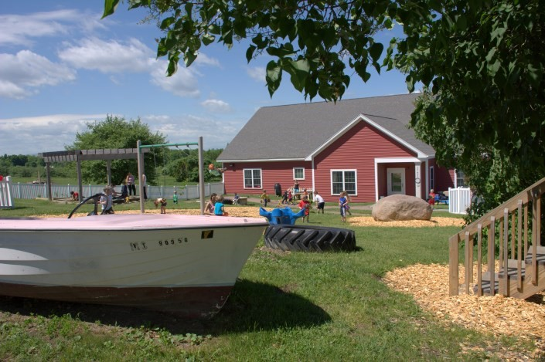  Summer Camp 2021  Together building  Strong children and confident families
CIPCC SUMMER CAMP 2021  CIPCC Summer Camp programs are a high quality option for school aged chilDreN, providing full day care during the summer months. our program is hosted in our new Classroom attached to the back of the farm house!  Our program provides breakfast, lunch and an afternoon snack daily.  We strive to offer a variety of enriching activities and walking field trips during vacation camps. | CIPCC SUMMER CAMP 2021  TUition Prices & HOurs of Operation  Vacation Camp 7:30 am – 5:00 pm  Full time: $185.00  Part time: $42.50 (per day)  Join us for a fun filled summer!!  Date Theme  06/21—06/25 European Week  06/28—07/02 Safari  07/05—07/09 Olympic Week  07/12—07/16 Time Travelers  07/19—07/23 Challenge Week  07/26—07/30 Media Week  08/02—08/06 Anything goes  08/09—08/13 Diversity  08/16—08/20 Closed  Each week will be filled with activities that will allow children to use their imagination, work together and most importantly build friendships!  **Our camp offers families the flexibility to choose what weeks they would like to attend without paying for weeks they will not need.  **To sign up please call or email with the weeks that you would like your child to attend. Space is limited so once you sign up you will be responsible for tuition that week. | CIPCC SUMMER CAMP 2021  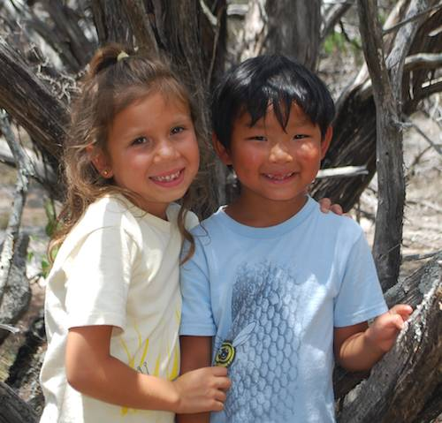  7:30 – 9:30 Arrival & Free play  9:30 – 10:00 Breakfast  10:00 – 11:00 Themed activities  11:00 – 12:00 Outdoor play  12:30 – 1:00 Lunch  1:00 – 1:30 Quiet time  1:30 – 3:00 Choice time (Field trip, art, movement or music)  3:00 – 3:30 Afternoon snack  3:30 – 4:30 Outdoor play  4:30-5:00 Free play & pick up

